**Print all ASCII Characters with their Values in Java**

Characters stored using ASCII code are 256. Each ASCII character stored in computer system, using eight bits of information, that gives **28** or **256** characters.

The Java program given below, prints all the ASCII characters along with their values.

public class Lp1

{

public static void main(String[] args)

{

int ASCII;

char ch;

Scanner scan = new Scanner(System.in);

System.out.println("ASCII\t\tCharacter");

for(ASCII=0; ASCII<=255; ASCII++)

{

ch = (char)ASCII;

System.out.println(ASCII + "\t\t" +ch);

}

}

## Count Total Number of Digits in Java using while Loop

The question is, *write a Java program to count the number of digits available in a given number using****while****loop.* The program given below is the answer to this question:

import java.util.Scanner;

public class CodesCracker

{

public static void main(String[] args)

{

int num, totalDigits=0;

Scanner s = new Scanner(System.in);

System.out.print("Enter a Number: ");

num = s.nextInt();

while(num!=0)

{

totalDigits++;

num = num/10;

}

System.out.println("\nThe Total Number of Digits = " +totalDigits);

}

}

Here is its sample run with user input **10294** as number to count all of its digits:

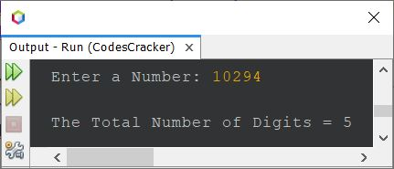

**Reverse a Number in Java using while Loop**

The question is, *write a Java program to reverse a number. The number to reverse, must be received by user at run-time of the program.* The answer to this question, is following program:

import java.util.Scanner;

public class CodesCracker

{

public static void main(String[] args)

{

int num, rem, rev=0;

Scanner s = new Scanner(System.in);

System.out.print("Enter a Number: ");

num = s.nextInt();

while(num!=0)

{

rem = num%10;

rev = (rev*10) + rem;

num = num/10;

}

System.out.println("\nReverse = " +rev);

}

}

The snapshot given below shows the sample run of above Java program, with user input **1034** as number to reverse:

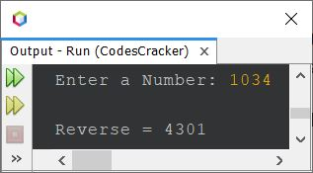

**Print Fibonacci Series in Java upto n Terms**

The question is, *write a Java program to print Fibonacci series upto****n****. The value of****n****must be received by user at run-time of the program.* For example, if user enters **5** as value of **n**, then the program should print first 5 terms of Fibonacci series. The program given below is its answer:

import java.util.Scanner;

public class CodesCracker

{

public static void main(String[] args)

{

int a=0, b=1, c=0, n;

Scanner s = new Scanner(System.in);

System.out.print("Enter the value of n: ");

n = s.nextInt();

System.out.print("\nFibonacci Series: " +a+ " " +b+ " ");

c = a+b;

n = n-2;

while(n>0)

{

System.out.print(c+ " ");

a = b;

b = c;

c = a+b;

n--;

}

}

}

The snapshot given below shows the sample run of above Java program with user input **10** as value of **n** to find and print first 10 numbers/terms of Fibonacci series:

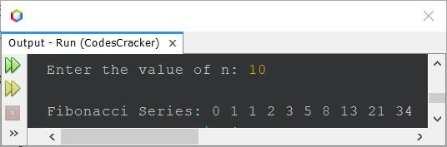

## Print Multiplication Table of 2 in Java

The question is, *write a Java program to print multiplication table of 2*. The program given below is its answer:

public class CodesCracker

{

public static void main(String[] args)

{

int num=2, i;

System.out.println("\n---Multiplication Table of 2---");

for(i=1; i<=10; i++)

System.out.println(num*i);

}

}

The snapshot given below shows the sample output produced by above program, on printing the multiplication table of 2

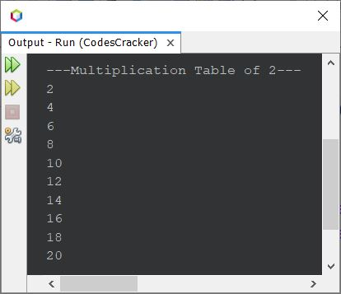

**Check Palindrome Number in Java**

The question is, *write a Java program to check whether a given number is a palindrome number or not. The number must be received by user at run-time of the program.* The program given below is its answer:

import java.util.Scanner;

public class CodesCracker

{

public static void main(String[] args)

{

int num, rev=0, rem, temp;

Scanner scan = new Scanner(System.in);

System.out.print("Enter a Number: ");

num = scan.nextInt();

temp = num;

while(temp!=0)

{

rem = temp%10;

rev = (rev*10) + rem;

temp = temp/10;

}

if(num==rev)

System.out.println("\nIt is a Palindrome Number.");

else

System.out.println("\nIt is not a Palindrome Number.");

}

}

The snapshot given below shows the sample run of above Java program on checking whether a given number is a palindrome number or not, with user input **12321**:

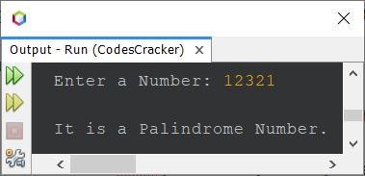

**Find Factorial in Java using for Loop**

The question is, *write a Java program to find factorial of a number. The number must be received by user at run-time of the program.* The answer to this question, is the program given below:

import java.util.Scanner;

public class CodesCracker

{

public static void main(String[] args)

{

int num, i, fact=1;

Scanner s = new Scanner(System.in);

System.out.print("Enter a Number: ");

num = s.nextInt();

for(i=num; i>=1; i--)

{

fact = fact*i;

}

System.out.println("\nFactorial Result = " +fact);

}

}

The sample run of above Java program with user input **5** is shown in the snapshot given below:

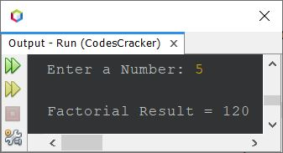

The above program can also be created in this way: